EuroPris AGM & Conference
Zaandam June 2016
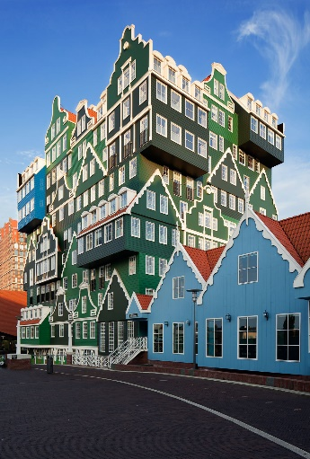
The EPEA was invited to attend EuroPris’ AGM and conference on June 13th 2016 in Zaandam, the Netherlands. As you may well know EuroPris is the recognised authority on prison policy and practice in Europe. It’s members are National Prison Services only. Read more on their website www.europris.org
Peter Hennephof, Director General of the DG of the hosting Dutch Prison Service, welcomed all participants and announced the 21st Council of Europe’s Conference of Directors of Prison that would be held in the 2 days following this meeting.
“La générosité à l’avenir existe en des actions dans le present” - Albert Camus
This is how the secretary to the Pc-CP of the CoE, Ilina Taneva explains why we should still invest in our work-environment, even in these days of economic regression.
A lot of speakers followed and gave an update on the expert groups that are part of the EuroPris organisation. Expert groups are forums where relevant experts can have topical discussion in smaller groups. The results of which will help countries implement legislation. We hear about recent developments concerning:
- Transfer of prisoners under Framework Decision 2008/909/JHA that will soon have factsheets available on the EP website.
- Foreign National prisoners – which mentions an interesting report by Dr. Roisin Mulgrew, read more here
- ICT in Prisons – with topics as télémedicin, data protection, video conferencing possibilities for family- and court purposes and tender management (that often takes too long in a fast ICT world).
- EPIS – the European Prison Information System was introduced in which more and more members have already included data on their Prison Services.
- Radicalisation – which is a real problem in almost all countries, chaplaincy and deradicalisation recommendations are seen as possible answers.
- Real estate and logistics – with the European problem of prison overcrowding, solutions are found in renting prisons abroad and the introduction of private partners in prison management, the so-called Private Public Partnerships -PPP’s.
- Family relation – we hear about two projects: COPE (Children of Prisoners Europe) more here and Invisible Walls (Wales) more here
- Staff Training – In which a statement is made to understand that, although the merits of e-learning are obvious, staff also benefits most from blended learning.
After a panel discussion on overcrowding and different solution and their possibilities, the Annual General Meeting took place, followed by presentations of the projects in which EuroPris takes part.
We heard about the following projects: STEPS2, Prisons of the Future, ECOPRIS, IDECOM, R2PRIS, FORINER and Improving conditions and finding alternatives to detention.
For more information please click on the link: http://www.europris.org/projects/
Apart from meeting relevant stakeholders in European Prisons and discussing some ideas of how EuroPris and EPEA can work together, I was pleased to attend this conference and personally learned a lot on topics that were in a direct or indirect way connected to our EPEA core business, prison education.

